How to Start a Student Business (That Funds Microloans)
A short, practical guide for students who want to start a simple business and use their earnings to fund microloans through Kiva. No experience required!

1. Start With a Simple Idea

Start small. Sell something people already want—food, tutoring, photography, design, car washing, or event services. If people will pay for it, it’s a valid business.

2. Get Basic Startup Money

You don’t need much to begin. Many students start with savings, small handouts, or even a short-term loan from their school or club. Frostbite’s Frozen Ice started with a small school loan for a commercial grade machine that was paid back through sales.

3. Make a Simple Plan
Decide what you’re selling, how much it costs to make, and how much you’ll charge. Pick where and when you’ll sell. Keep it simple and accessible. Fall fests, summer camps, and neighborhood streets are great places to sell!


4. Sell Consistently

Show up when you say you will. Consistency matters more than creativity. Most student businesses fail because they stop too early.

5. Turn Profits Into Impact
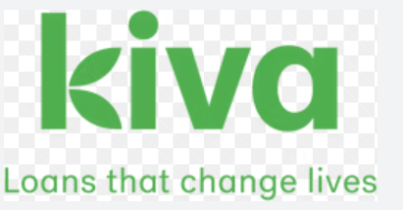
Set aside part of your profits to fund microloans through your Kiva lending team. Track repayments and reinvest them to grow your impact over time.

Real Student Examples
• Frostbite’s Frozen Ice — snow cones at school events, started with a small school loan
• Curry Kart — a student-run food venture
 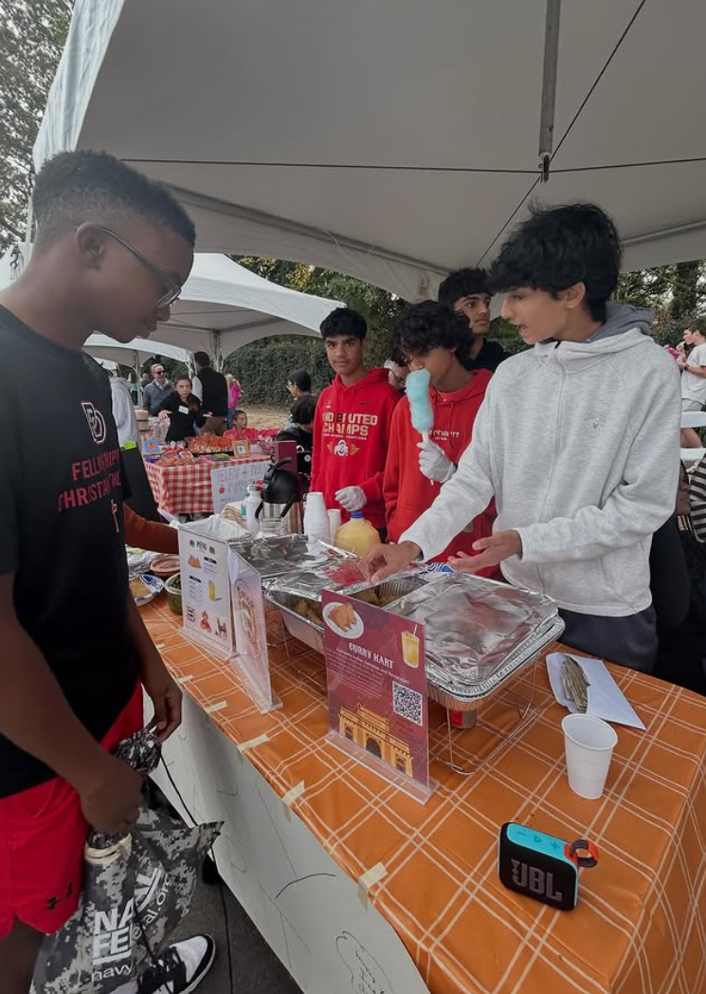
Both businesses generated earned capital that funded microloans instead of relying on donations. Frostbite’s made 60 loans amounting to $1500 in just 1 year!

Final Takeaway
You don’t need permission or a big budget. Start small, earn honestly, and turn your profits into opportunity for others.

